NAME: NAVODITAA A.R
ROLL NO: 241901071

8. PERFORM ROOTKIT DETECTION AND REMOVAL USING RKHUNTER TOOL
DATE: 18/03/2026
Aim:To perform real-time file system analysis on a Linux system to identify an attacker's artefacts.
Procedure:
- Log into TryHackMe and open the Linux File System Analysis room.
- Explore the Linux file system structure and important directories.
- Perform analysis to identify suspicious files and attacker artefacts.
- Examine logs and metadata for signs of unauthorized activity.
- Use basic commands and tools to investigate file changes. 6. Complete the tasks and answer the questions in the room.
7. Review findings and confirm completion.
Tasks:
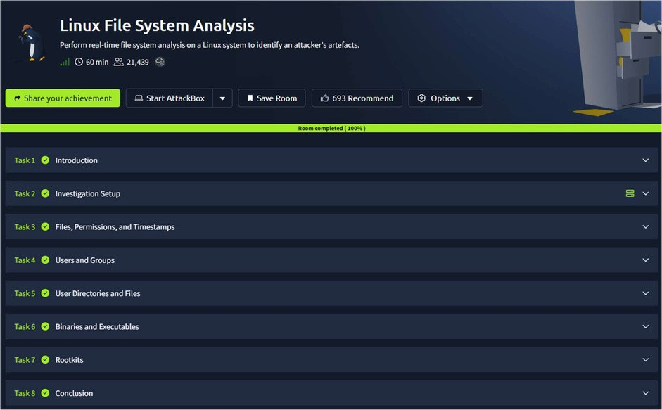
TASK 1 - Introduction
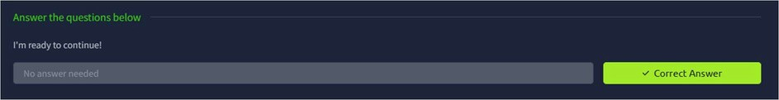
TASK 2 – Investigation Setup
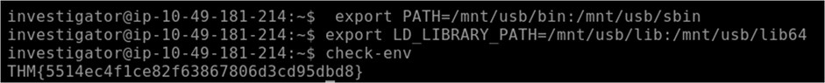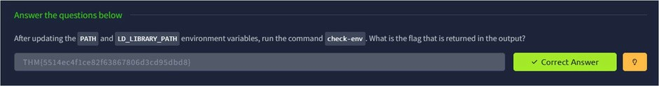
TASK 3 – Files, Permissions and Timestamps
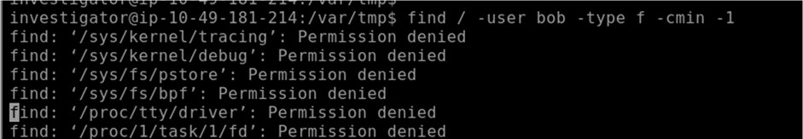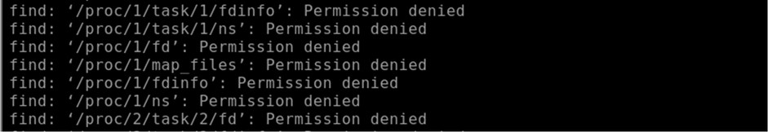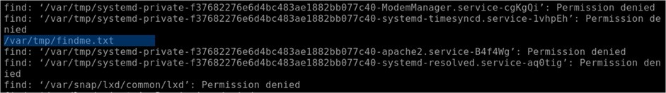
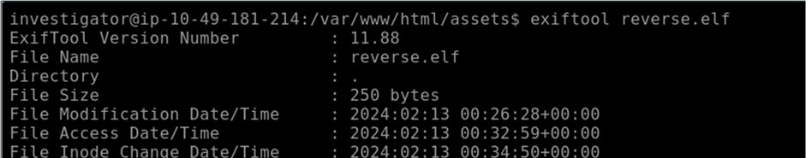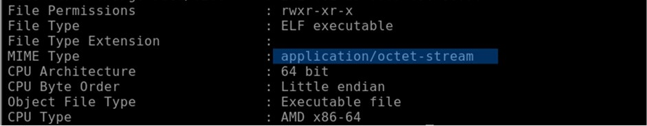
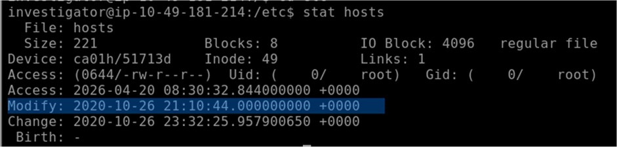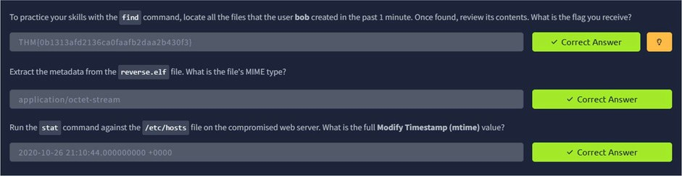
TASK 4 – Users and Groups
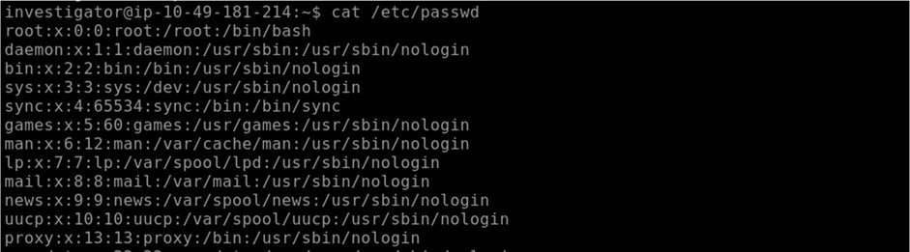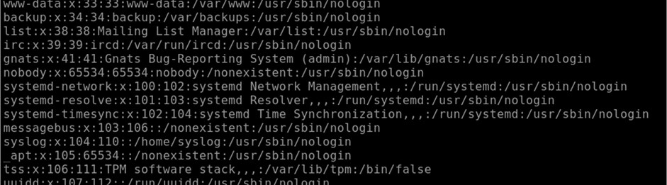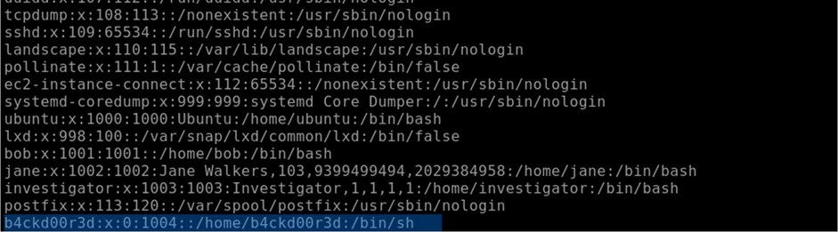
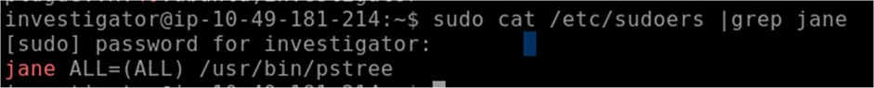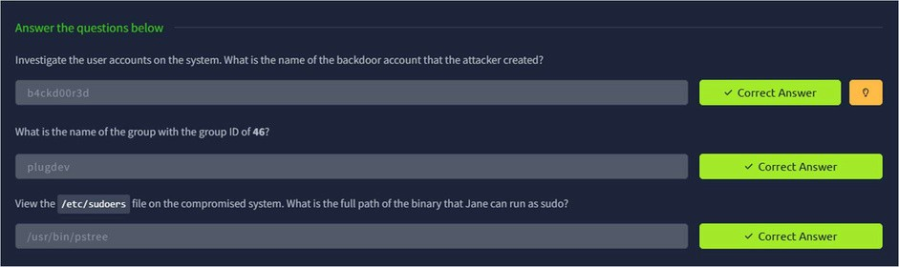
TASK 5 – User Diresctories and Files
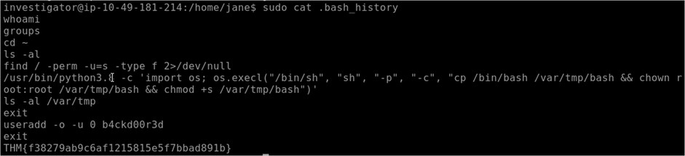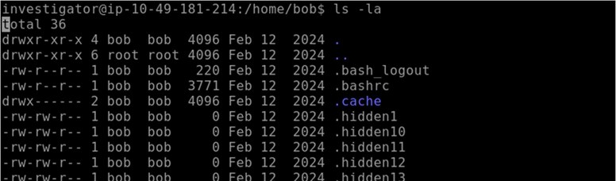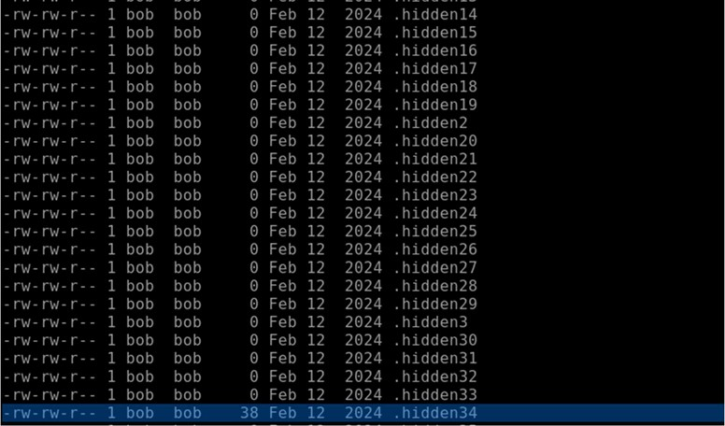
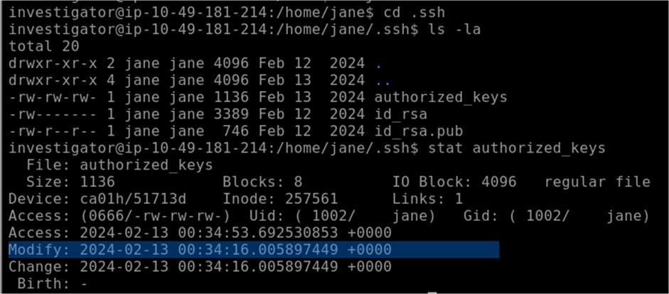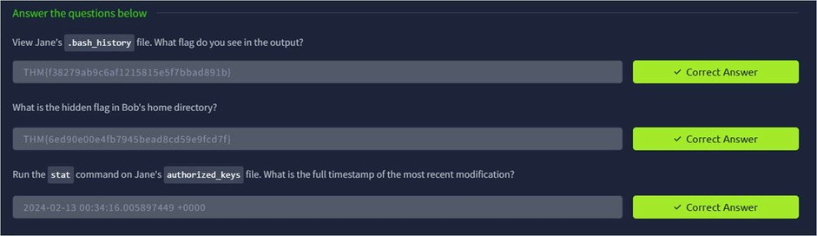
TASK 6 – Binaries and Executables
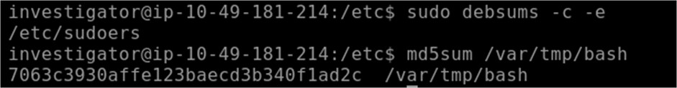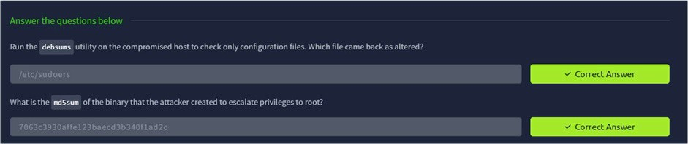
TASK 7 - Rootkits
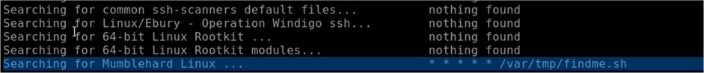
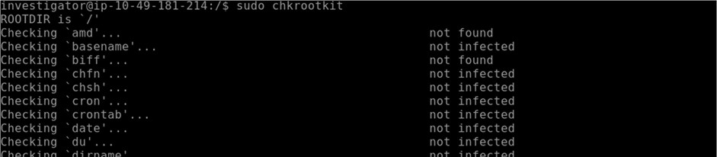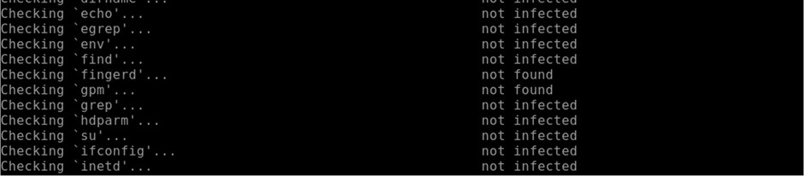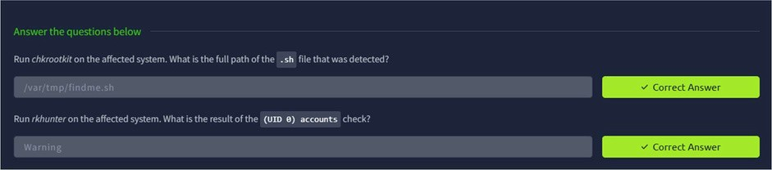
TASK 8 - Conclusion
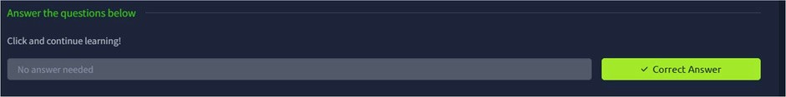
Result:
Thus the TryHackMe room Linux File System Analysis was completed successfully.

